May 2022
Adding Life To Your Years
Skees Senior  Activity Center  7431 U.S. 42  Florence, KY  Center Manager  Christine Miskell  CMiskell@myy.org  Assistant Mgr.  Jeannie Hoffman  JHoffman@myy.org  Phone:  (859) 282-4061  Building & Fitness Room  Monday - Friday  8:30a –2:30p  Meals on Wheels  $1 Donation  Call the center 48 hrs ahead to reserve meal.  Lunch arrives 11:30  Meal must be eaten at the center. | Monday | Tuesday | Wednesday | Thursday | Friday
 | 2)  9am Breakfast Bingo  Self-Drive to Story Point  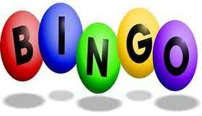  9:00- Mah-Jong  10:00 Cards  12:30- Art Lessons | 3)  9:15 – Silver Sneaker Yoga  10:30- Cards  10:30 –Silver Sneaker  11:45- Beginner Line Dance  12:15- Regular Line Dance | 4)  9:00 – Bridge Class  10:45- Gentle Mat Yoga  12:30- Bingo | 5)  9:30- Tai Chi Arthritis  10:30 –Cards  12- Silver Sneaker Classic  1:00 – Chair Volleyball | 6) No Mah-Jong Today  9:00 Private Sewing Group  9:30 –Dance Fit  11:00  Hosted By Humana  RSVP- Must Attend the Learn to Have the Lunch  12:30- BINGO
 | 9)  9:00- Mah-Jong  10:00 Cards  12:30- Art Lessons | 10)  9:15 – Silver Sneaker Yoga  10:30- Cards  10:30 –Silver Sneaker  11:45- Beginner Line Dance  12:15- Regular Line Dance | 11) 9:00 – Bridge Class  10:45- Gentle Mat Yoga  11:00- Discovering Your  Tree  12:30- Bingo | 12)  9:30- Tai Chi Arthritis  10:30 –Cards  12- Silver Sneaker Classic  1:00 – Chair Volleyball | 13)  9:00- Mah-Jong  9:30 –Dance Fit  12:30- BINGO
 | 16) Commodities  9:00 Mah-Jong  10:00 Cards  12:30 Art Lessons | 17)  9:15 – Silver Sneaker Yoga  10:30- Cards  10:30 –Silver Sneaker  11:45- Beginner Line Dance  12:15- Regular Line Dance | 18) Derby Dinner Trip  9am Pick-up at RC Durr  9:00 Bridge Class  10:45-Gentle Mat Yoga  12:00-Nutrition Ed  with Diane Mason  12:30- Bingo | 19)  9:30- Tai Chi Arthritis  10:30 –Cards  12- Silver Sneaker Classic  1:00 – Chair Volleyball | 20)  9:00- Mah-Jong  9:30 –Dance Fit  12:30- BINGO
 | 23)  9:00- Mah-Jong  10:00 Cards  12:30- Art Lessons | 24)  9:15 – Silver Sneaker Yoga  10:30- Cards  10:30 –Silver Sneaker  11:45- Beginner Line Dance  12:15- Regular Line Dance | 25)  9:00 – Bridge Class  10:45- Gentle Mat Yoga  12:30- Bingo | 26)  9:30- Tai Chi Arthritis  10:30 –Cards  12- Silver Sneaker Classic  1:00 – Chair Volleyball | 27)  9:00- Mah-Jong  9:30 –Dance Fit  12:30- BINGO
 | 30) Center Closed  Memorial Day | 31)  9:15 – Silver Sneaker Yoga  10:30- Cards  10:30 –Silver Sneaker  11:45- Beginner Line Dance  12:15- Regular Line Dance | 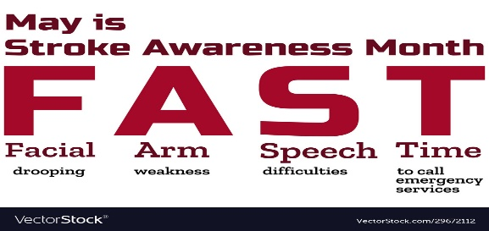 |  | RSVP at the Front Desk  Lunch & Learn  Friday June 3rd @ 11am  Hosted by:  Bluegrass Navigators  ** To receive a lunch,  You must be at the presentation
Note: Please call only 1 day in advance to reserve a spot for exercise classes. Remember to bring your own drink / snack if needed. There is hand sanitizer and wipes throughout the center for your use. Please do your part by sanitizing any equipment / tables / chairs that you use during your visit. Please remember to wash / sanitize your hands often. Thank you for your help by providing a safe environment.

